Hotel Management System – Task 2 Submission

GitHub Repository: [Paste your GitHub Link Here]

Group Members

Name | Role | Registration Number
Abdullah | Idea Machine & Sketch Artist | FA24BCS-217
Sattam | DS Wizard & Narrator | FA24BCS-204
Ali Ibrahim | Data Detective & Organizer | FA24BCS-203

Task 2 – Data Structure Design and Pseudocode Development

- Data Structure Planning Table (DS-Plan.md)

Operation | Data Structure | Reason for Choosing the DS
Add Booking | Array | Rooms stored in fixed indexes allowing fast acce
Search Guest | Linked List | Sequential node traversal makes searching simp
Manage Check-in Tasks | Stack | LIFO behavior fits task processing order.
Delete Booking | Linked List | Easy node deletion without STL.
Store Sorted Rooms | Binary Search Tree | Manual BST keeps rooms sorted without STL.

- Operation Flow Explanation

Operation: Add Booking
Stores guest name, room number, and days.
  - Data Structure: Array
  - Reason: Direct indexing fits fixed room structure.
  - User Interaction: User inputs booking info, system saves in room array.

Operation: Search Guest
Finds a guest in the linked list.
  - Data Structure: Linked List

ss.
le.

  - Reason: Sequential search node by node.
  - User Interaction: User enters name to lookup.

Operation: Manage Check-in Tasks
Handles cleaning, key assignment, verification, etc.
  - Data Structure: Stack
  - Reason: Last added task executed first (LIFO).
  - User Interaction: System pushes tasks during booking.

Pseudocode (Pseudocode.md)

Function: AddBooking()
Function AddBooking(name, room, days): If rooms[room] is empty: rooms[room].name = name rooms[room].days = days InsertNodeLinkedList(name) PushTask("Check-in Task") Return "Booking Added" Else: Return "Room Already Occupied"

Function: SearchGuest()
Function SearchGuest(name): temp = head While temp != NULL: If temp.name == name: Return temp temp = temp.next Return "Guest Not Found"

Function: DeleteBooking()
Function DeleteBooking(name): DeleteNodeLinkedList(name) Clear room in array Return "Booking Deleted"

Function: PushTask()
Function PushTask(task): If top == MAX: Return "Stack Full" top = top + 1 stack[top] = task

Function: DisplayRooms()
Perform InOrderTraversal(BSTRoot) Print each room in sorted order

- Visual Diagram (Flowchart)
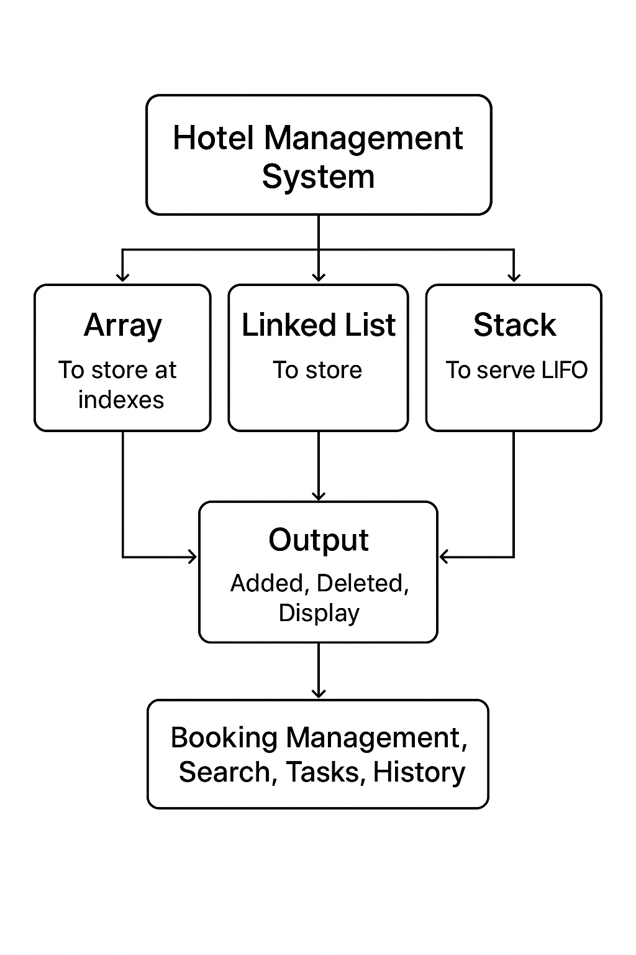

- GitHub Activity
- Upload DS-Plan.md
- Upload Pseudocode.md
- Upload Flowchart Image
- Each member makes at least one commit
- Use meaningful commit messages
- Repository updated regularly

